Assignment 3B: Nested loops & animations

1. Use a nested for-loop to draw a red-and-black checkerboard with green and blue checkers in their correct positions at the start of a checkers game.
2. Use a nested for-loop to create a fraction brick wall from 1 up to whatever fraction the user chooses.   
   Like this:  
   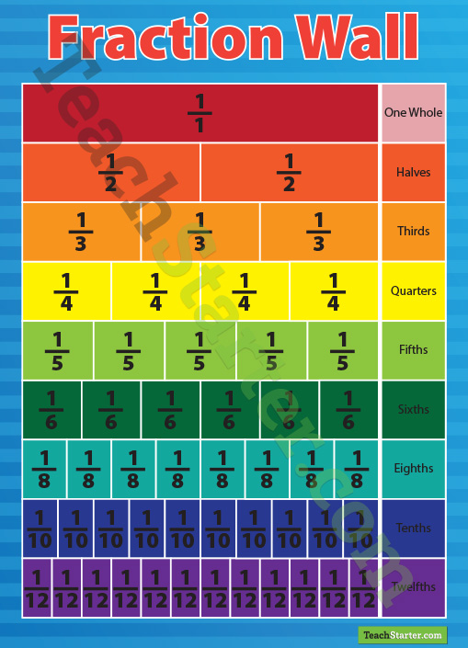

First, get your program to draw the boxes in the right sizes. Once you’ve got that working, get it to add the fraction labels.

1. Use a while-loop to make an animation of a circular pond ripple that expands from an inputted starting   
    point until it hits one of the edges of the drawing screen.
2. Expand Problem 3 so that as as soon as one ripple hits the wall, another ripple begins from the same   
    starting point and stops 10 pixels before the previous one did. Repeat this process for 50 ripples.